The Potter is in the Process
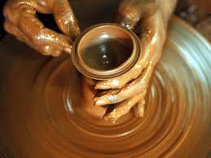

We acknowledge that the Potter is in the Process and that He will never lose His Focus on the clay; He will never lose Touch with the clay; and He will never Quit until His work with the clay is done. In this we contemplate and share the following considerations:
What would we ask of the Potter? What are our expectations of the Potter?
- Search us and Touch us Lord
- Heal us the hurts and wounds that linger as a result of things already forgiven
- Help us to face and deal with all of our struggles and not to quit when we feel overwhelmed by our struggles
- Have Your way and make us to be just as You see us, all that You want us to be
- We may get wonky [uncentered, unstable, shaky] in the Process but see us through those wonky moments
- Help us to hold on until our change comes
Likewise, as we have asked of the Potter, He has turned the questions back to us. The Potter asks us to contemplate what He might ask and expect of us in the Process.
- Consistency and Commitment
- Maintain Relationship, Unity and Fellowship with the Potter and one another
- Trust His love and love each other as the Potter loves us
- Be merciful toward one another, forgive and let it go
- Put our faith in the Potter and trust His Process, don’t stop believing
- Stay focused and true to the Process, accept His will and don’t fight the Process
- Be patient, hold on, don’t let go, don’t give up and be true to yourself as the Potter leads through the Process of Restoration, Renewal and Revival to BETTER!!!

